

# INTRODUCTION

# Overview

# This project involves the development of a sleep tracking app that aims to help users achieve better quality sleep. The app includes features such as sleep tracking, analysis of sleep patterns, personalized recommendations, and alarm/wake-up features.

* 1. Purpose

The purpose of the sleep tracking app project is to create a digital tool that helps users improve their sleep quality by tracking and analyzing their sleep patterns. The app aims to provide personalized insights and recommendations based on users' data, ultimately leading to better sleep hygiene and overall health.

1. **PROBLEM DEFINITION & DESIGN THINKING**
   1. Empathy Map

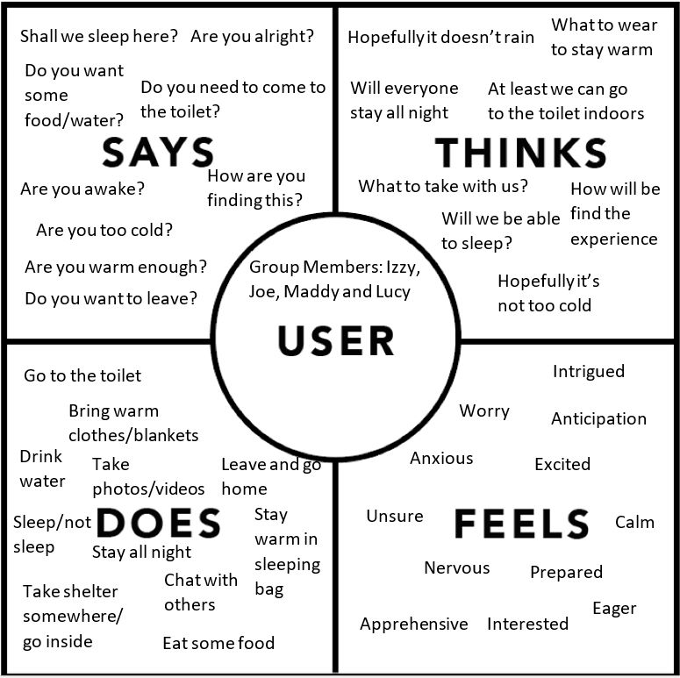

* 1. Ideation & Brainstorming Map

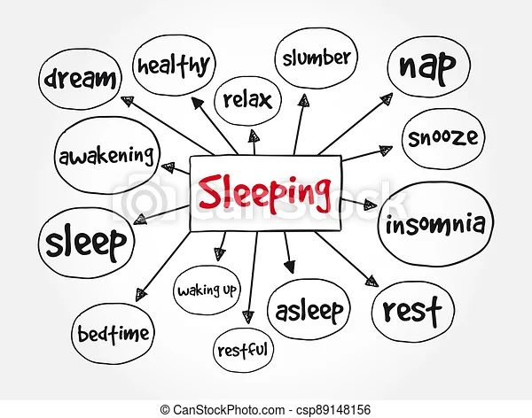

# RESULT

# Data Model

|  |  |
| --- | --- |
| **Object name** | **Fields in the Object** |
| Sign up | |  |  | | --- | --- | | Field label | Data type | | Username | String | | Password | String | | Email | String | |
| Log in | |  |  | | --- | --- | | Field label | Data type | | Username | String | | Password | String | |

# 

# The screenshots of your project activity along with the description.

# 

Sign Up :

It is a page where user have to register for creating new account for them , then only they can log in with that details

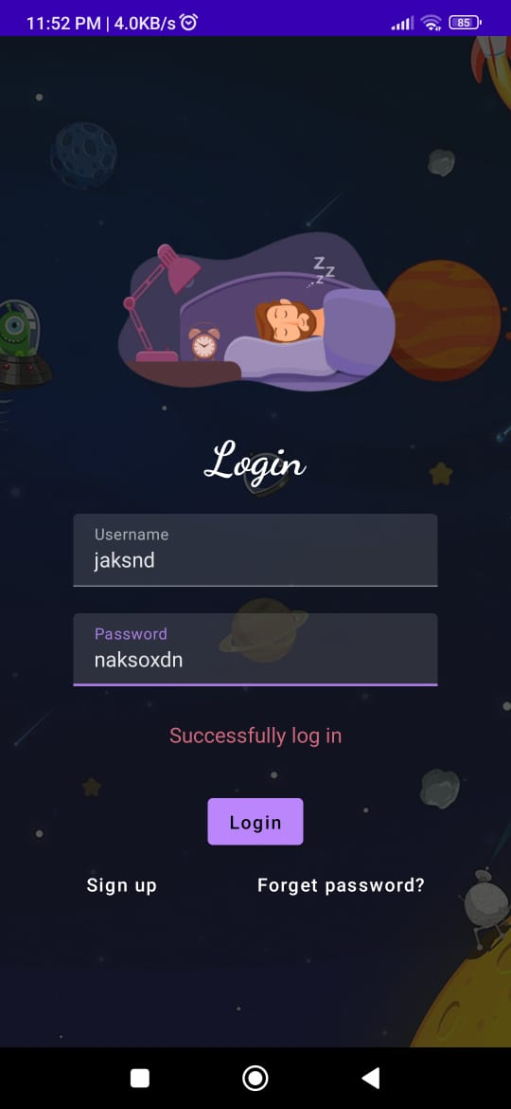

Login :

The user should enter a correct details to login

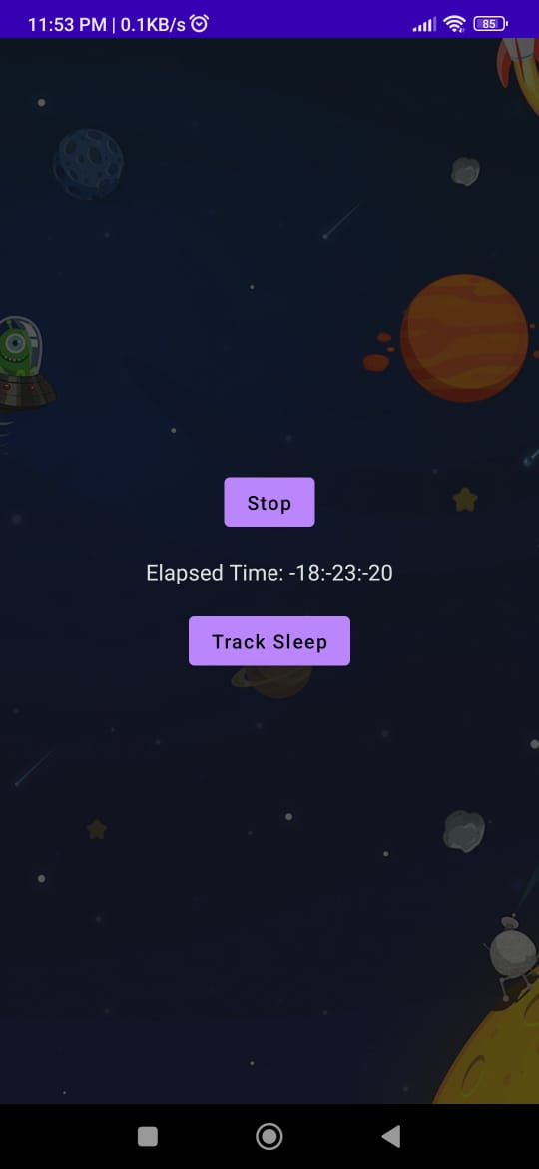

Elapsed time: sleep tracking is the duration of sleep, which can help users understand their sleep patterns and make improvements

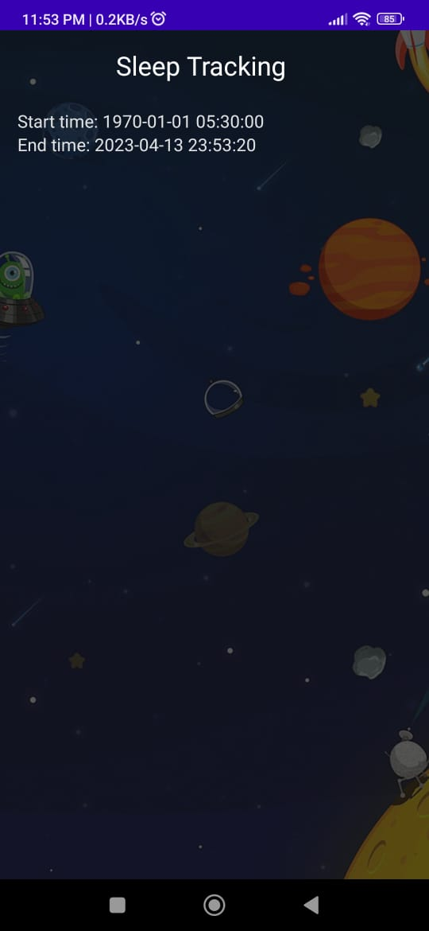

# GOOGLE DEVELOPER PROFILE PUBLIC URL

# Team lead – <https://g.dev/Linkesh>

# Team member 1 -<https://g.dev/>Rohith02

# Team member 2 -<https://g.dev/>Ranjit8877

# Team member 3 -<https://g.dev/>Sudarshan2233

1. **ADVANTAGES & DISADVANTAGE**

# Advantages :

# Helps users to understand their sleep patterns and identify areas for improvement

# Provides personalized recommendations for better sleep habits

# Can help users to feel more rested and refreshed during the day

# May assist in identifying potential sleep disorders or issues that require medical attention

# Can be a useful tool for tracking progress and achieving sleep-related goals

# Disadvantages :

# May not be entirely accurate in tracking sleep patterns or quality

# Requires consistent use and may be inconvenient for some users to wear or use regularly

# May create unnecessary anxiety or stress for users who become overly focused on sleep tracking data

# Can be expensive to purchase and maintain a sleep tracking device or app subscription

# May not be suitable for all individuals, such as those with certain medical conditions or disabilities.

# APPLICATIONS

This would involve continuously monitoring a user's sleep patterns, such as sleep duration, quality, and interruptions, and providing real-time feedback to the user.

1. **CONCLUSION**

# The sleep tracking app developed provides insights into sleep patterns, helping users to make adjustments to improve their sleep quality. The app's features make it a useful tool for tracking progress and achieving sleep-related goals.

1. **FUTURE SCOPE**

Future development could integrate wearable devices, AI, and community features. Partnerships with healthcare providers could allow for more comprehensive sleep analysis and treatment recommendations. These could help make a positive impact on individuals seeking to improve their sleep quality.